

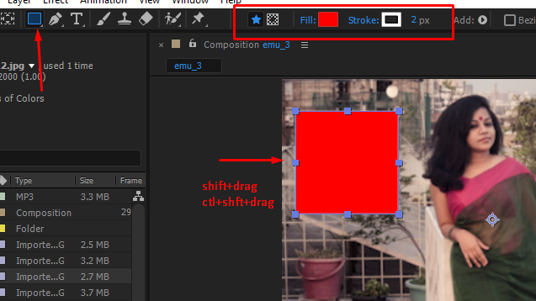

Shit + drag

Or

Shift +ctrl+ drag



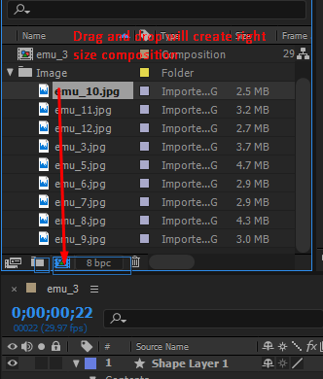

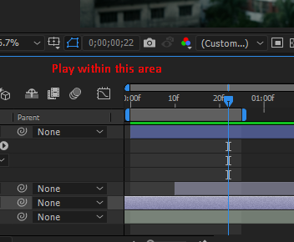

Ctl +] or [ moves layer up or down



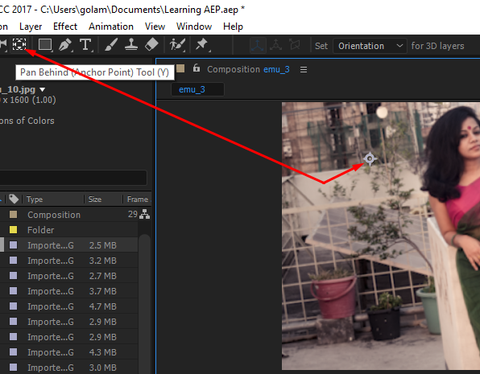

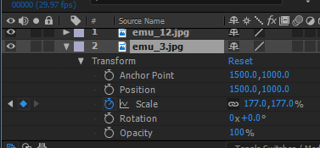

Anchorpoint – a

Position – p

Skale – s

Rotation – r

Opacity - t

Pressing any of them again – will colapse ...

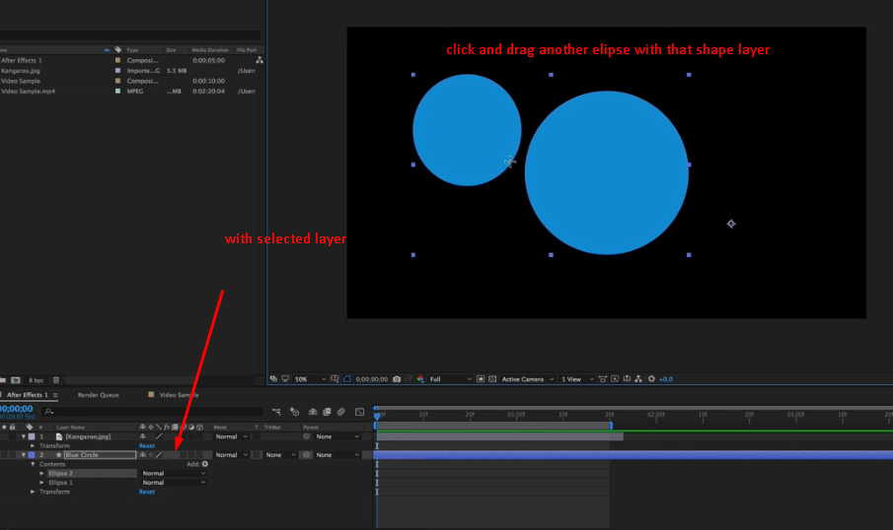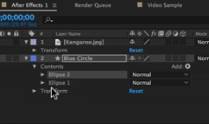

Pressing u will reveal all transformations with keyframes

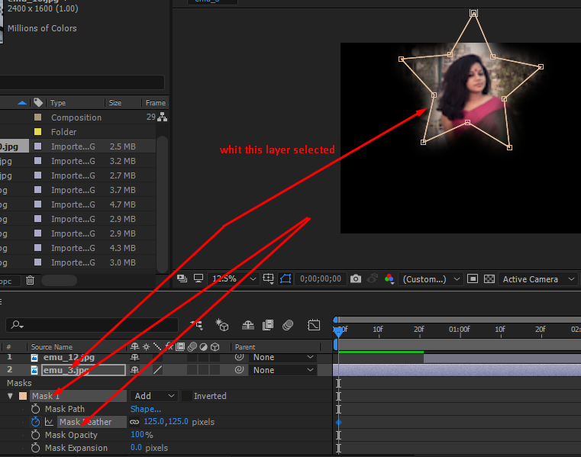



<https://www.videoschoolonline.com/the-ultimate-guide-to-finding-free-music-for-your-videos/>

<http://dig.ccmixter.org>

<https://www.videoschoolonline.com>

Section 3 keyframes



Build Everything from scratch

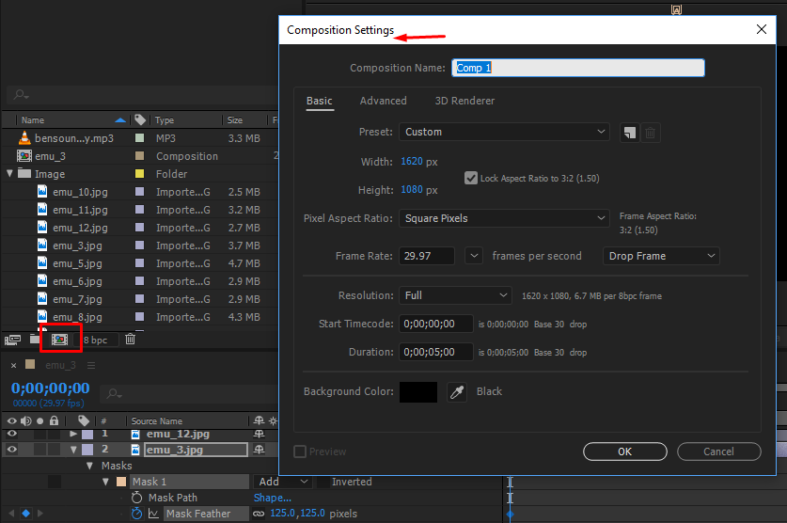

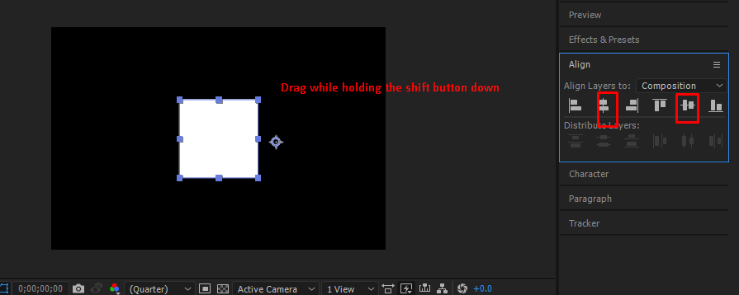

To animate in after effects we use keyframes.

29.97 frames per second.

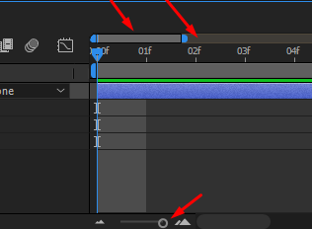

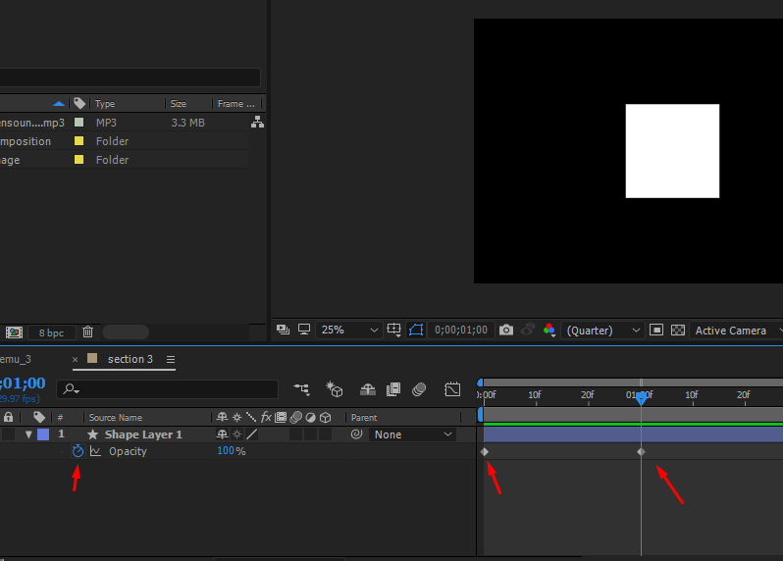

That little diamond is the keyframe

You can move around these key frames, cut copy or paste them.

That’s the basics of most things we are going to do in after effects.



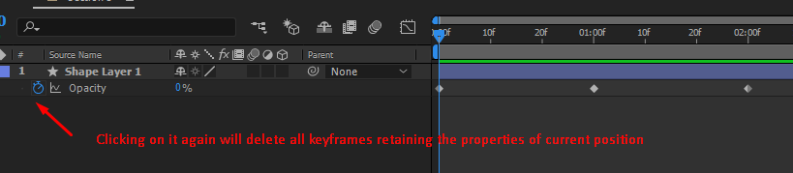

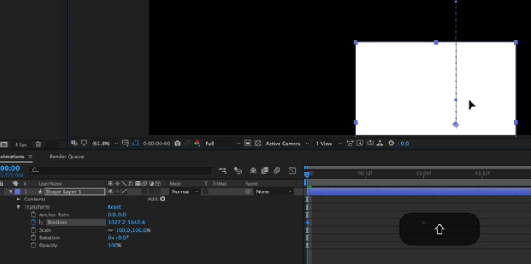

Press the shift button to keep it steady.

We can add more animation to the same object



Motion blur

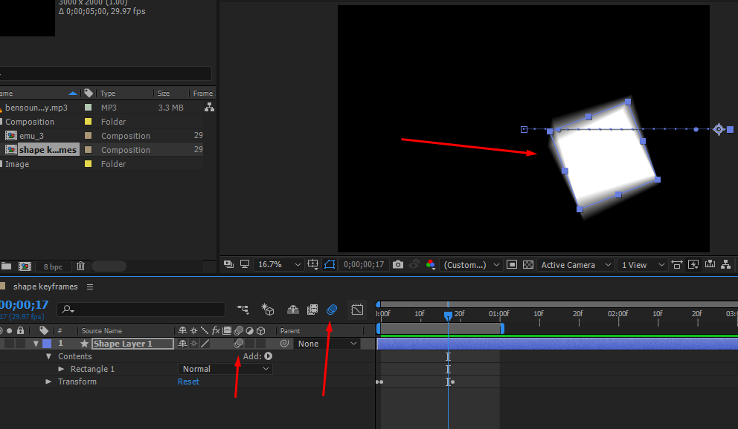

To add easy ease to a keyframes or set of key frames – select those key frames – right click the key frames – go to key frame assistance – select easy ease or you can just select keyframes and press f9

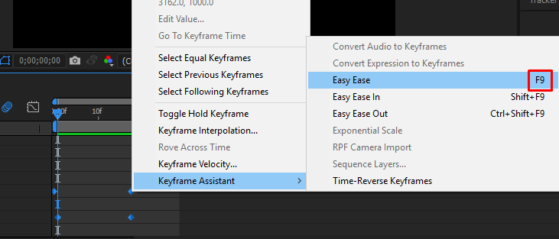

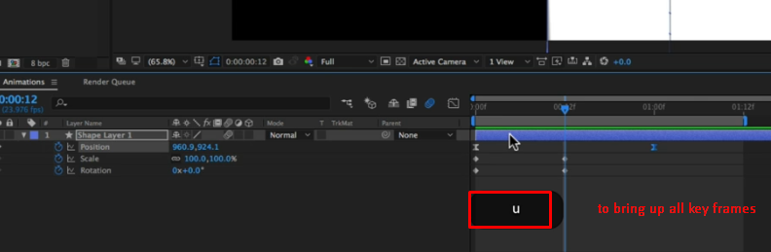



Open the graph editor

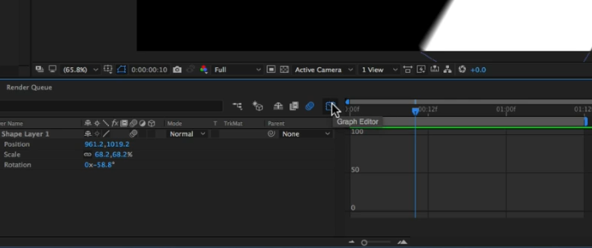

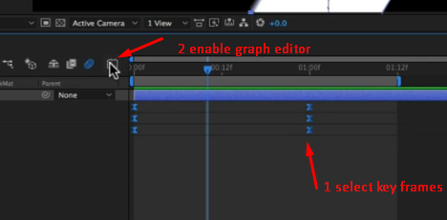

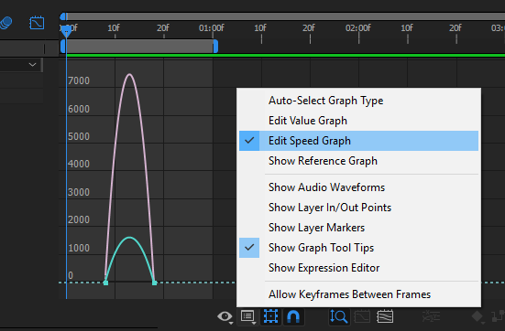

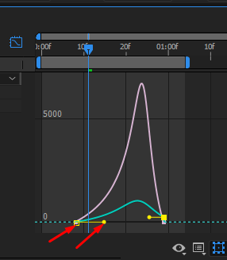

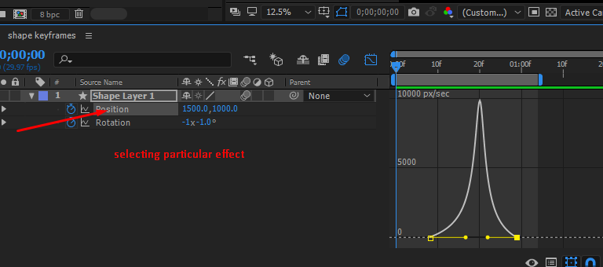

Keyframes + easy ease and motion blur + edit speed graph ; very much useful.



Revise one

This twenty minutes work out puts everything in practice that has been taught so far.

Helpful for recap.

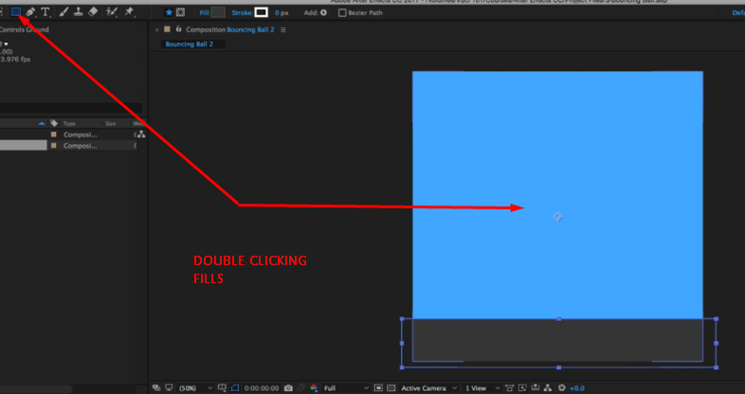

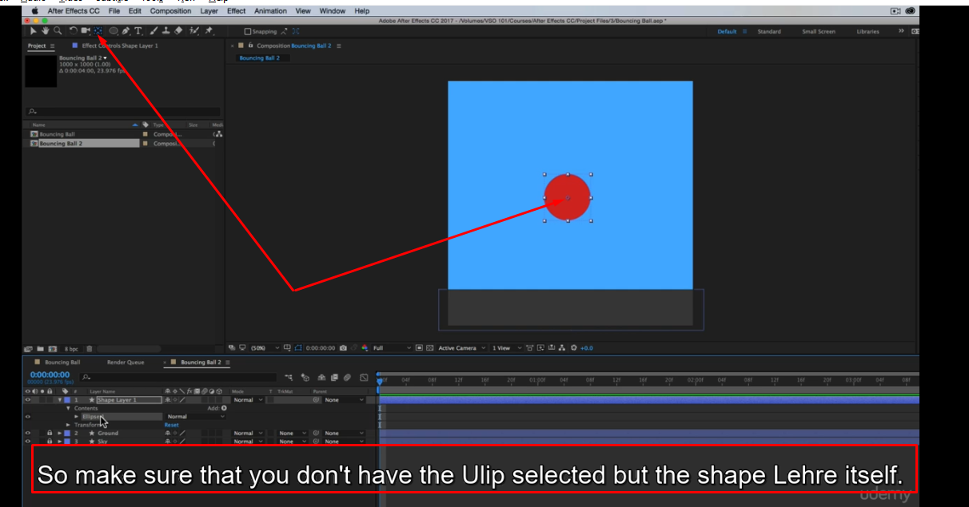

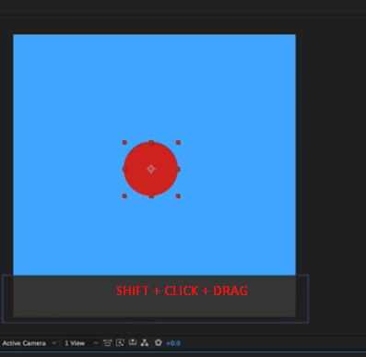

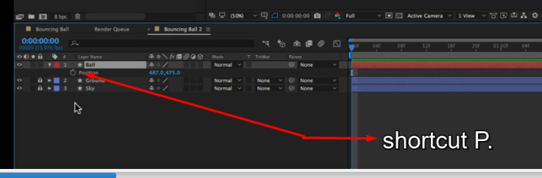

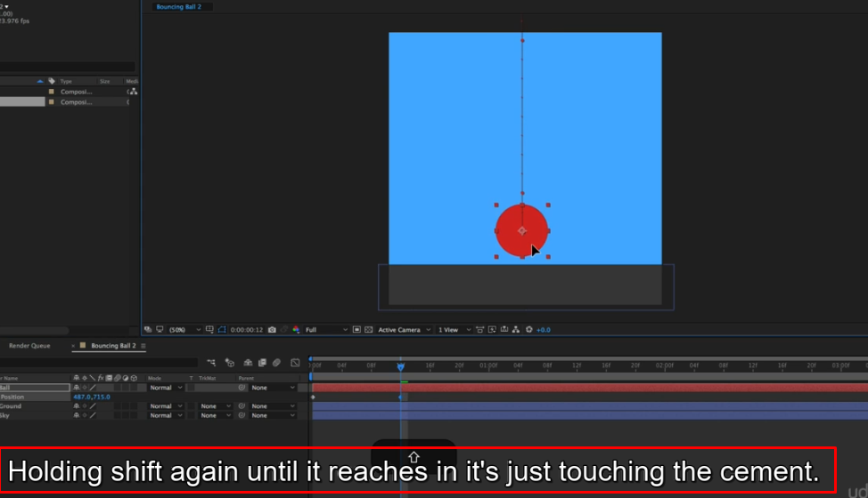

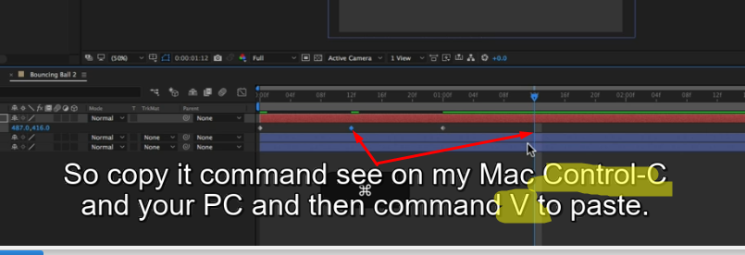

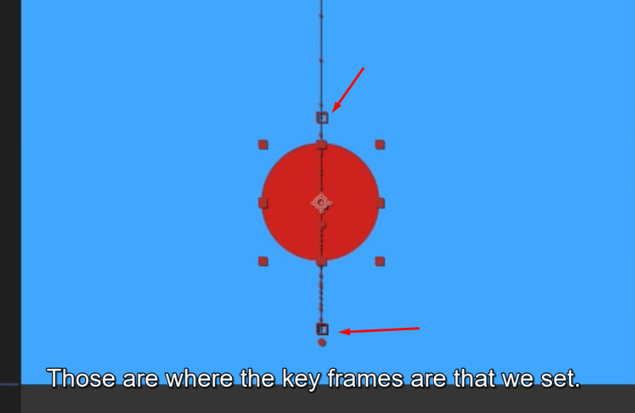

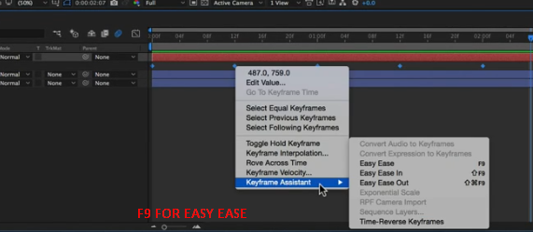

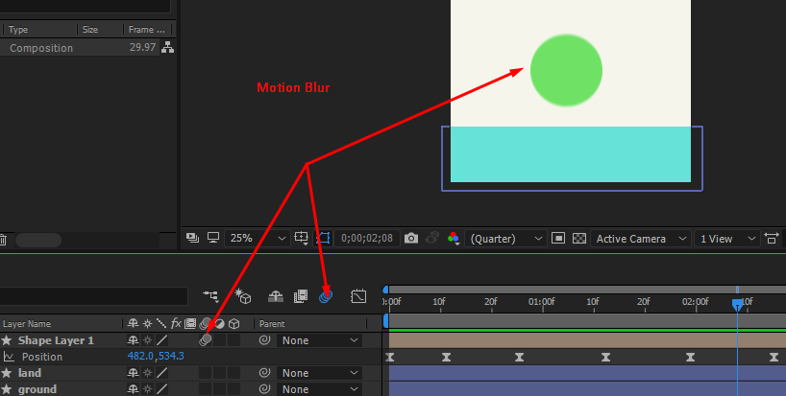

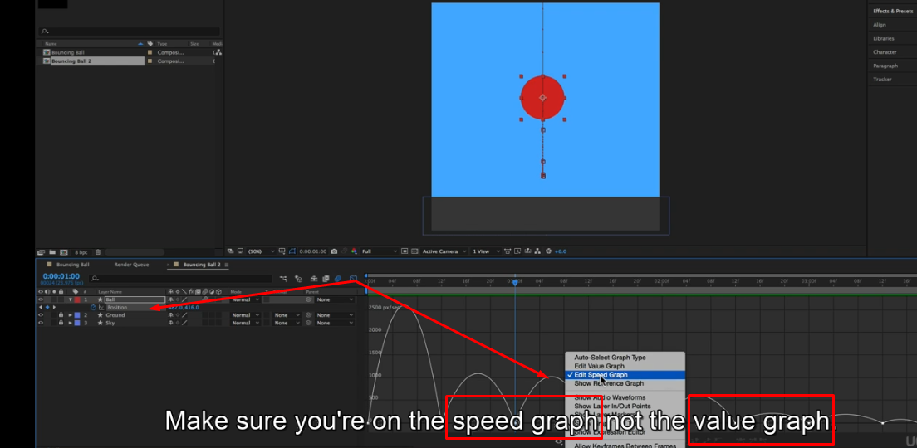

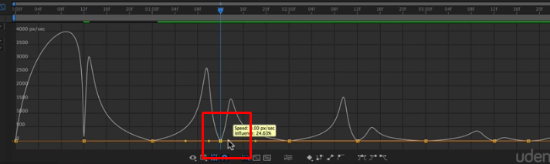

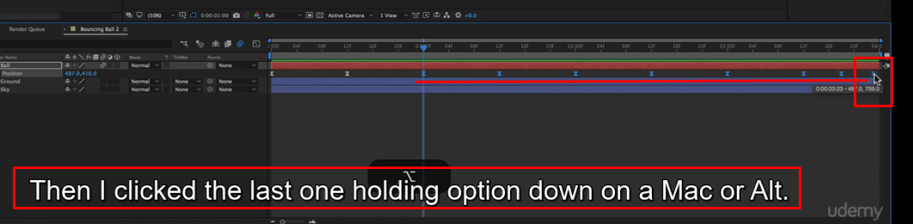

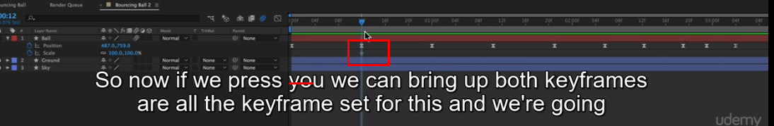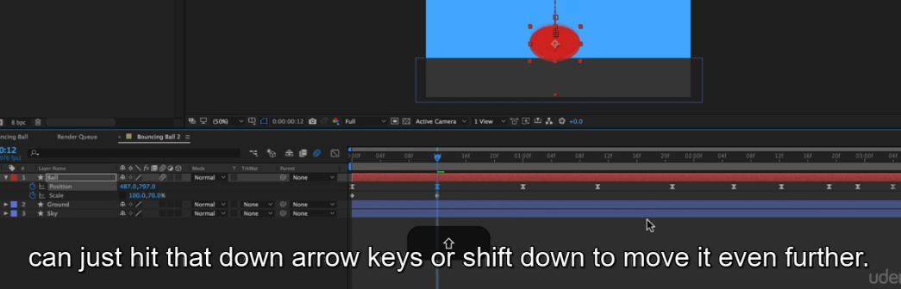

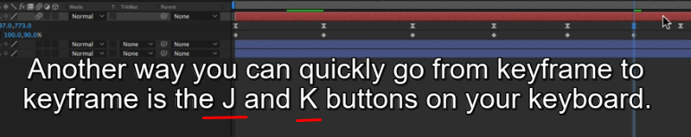

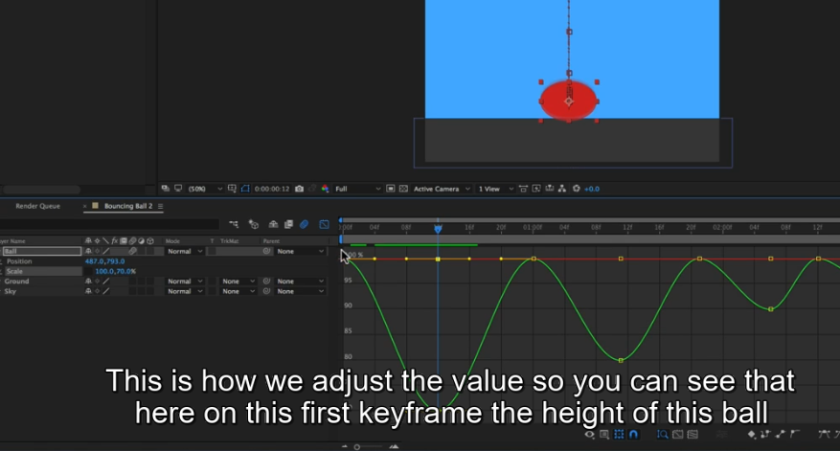





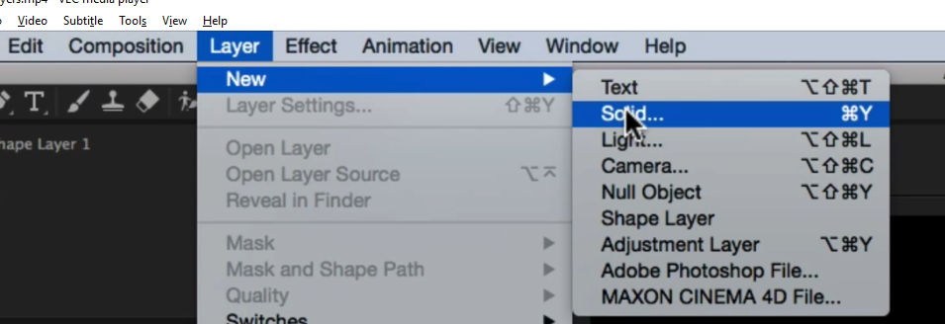

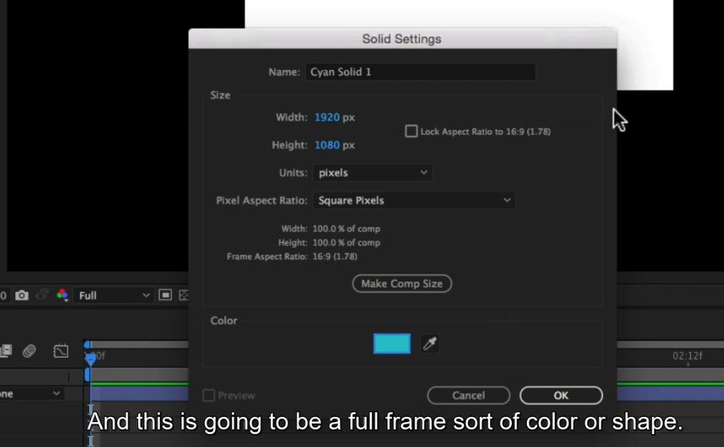

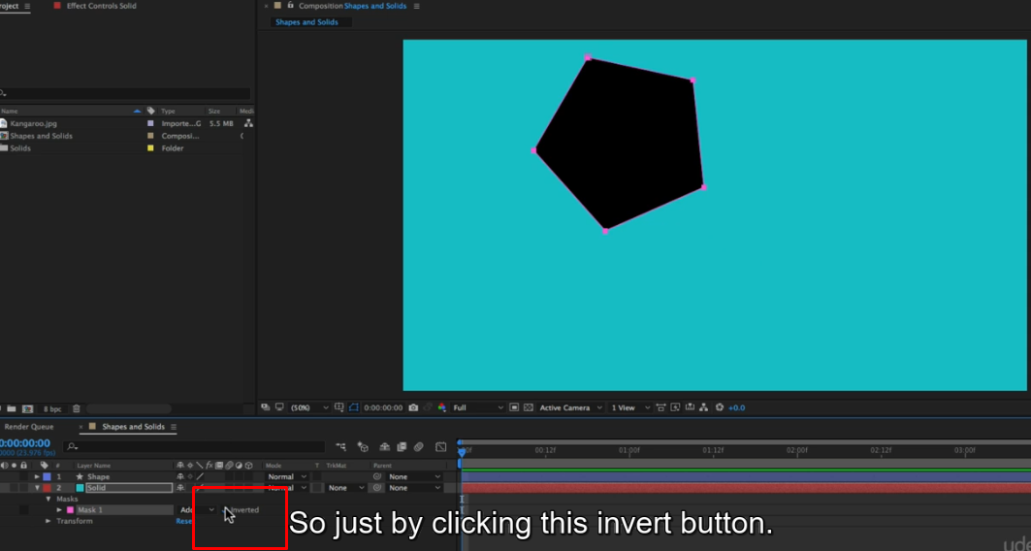

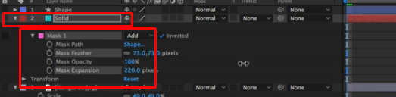

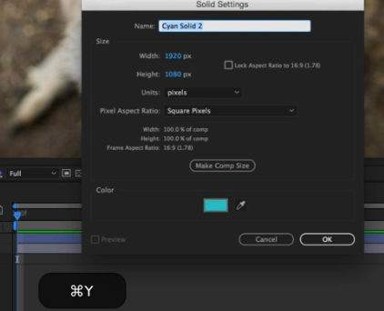

Create a vignette with solid layes – details in this video tutorial.

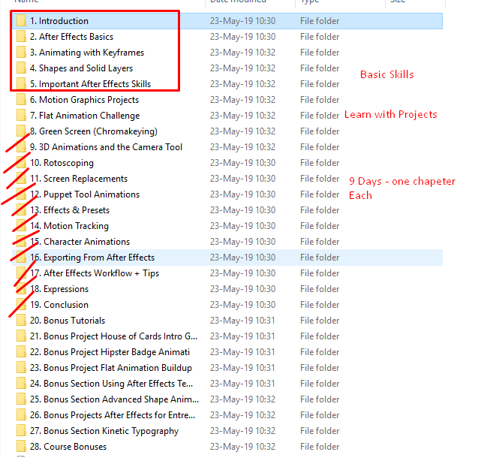



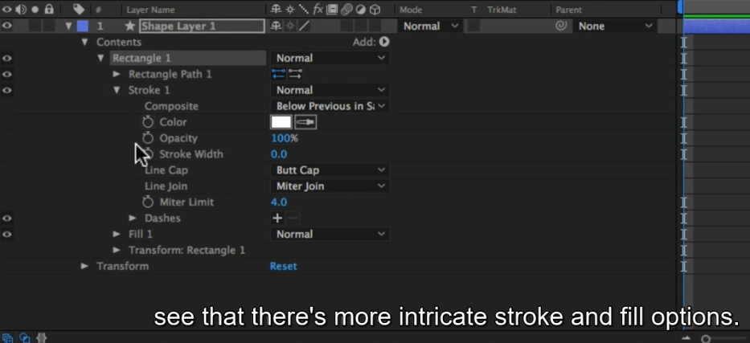

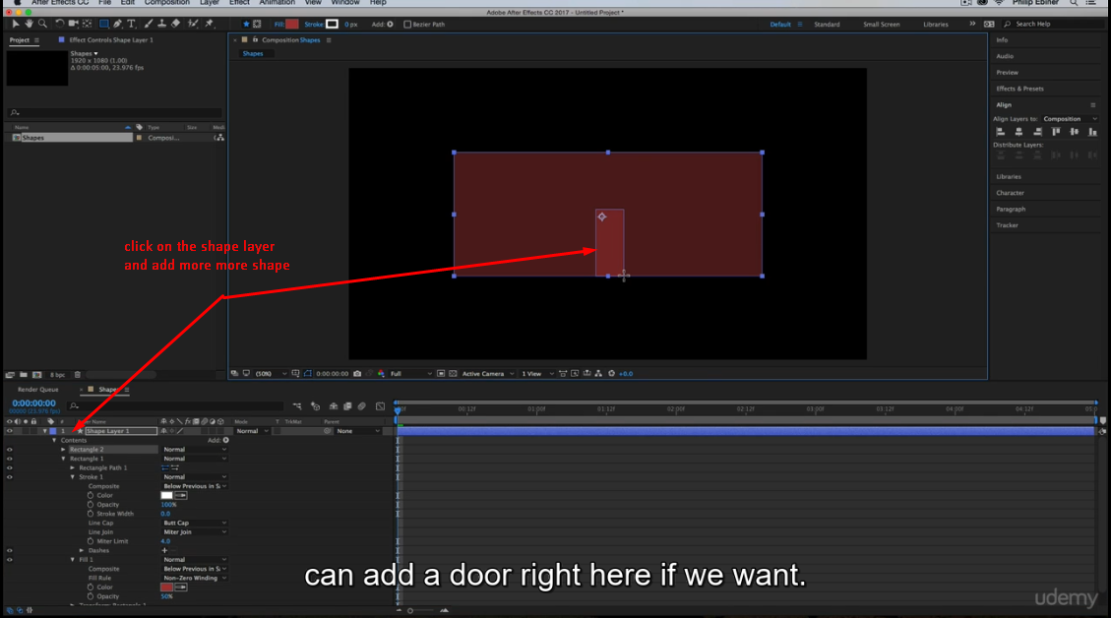

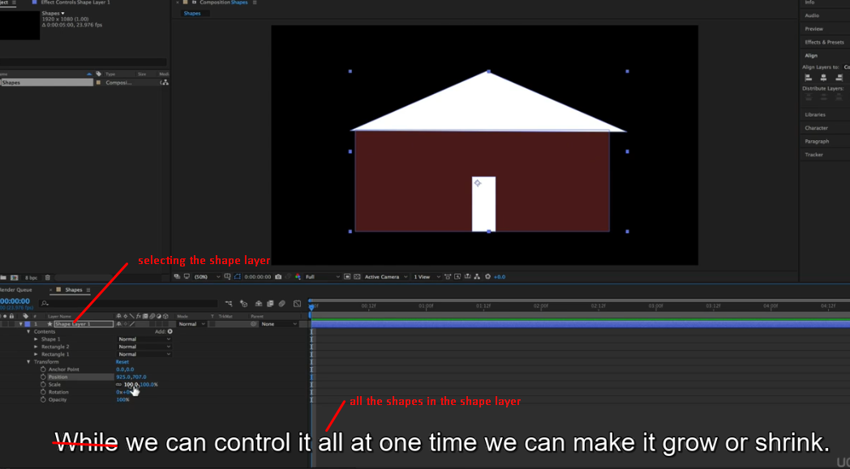

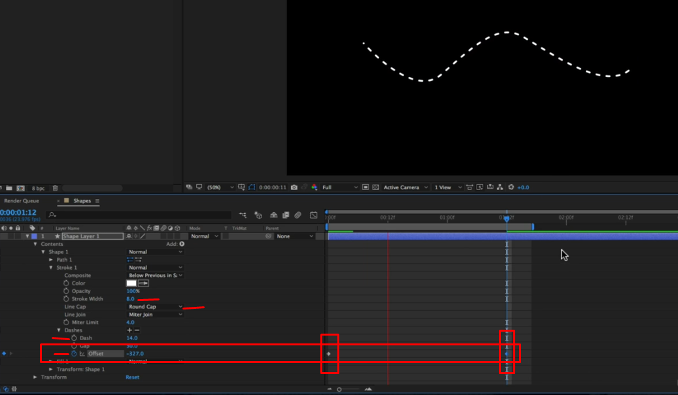

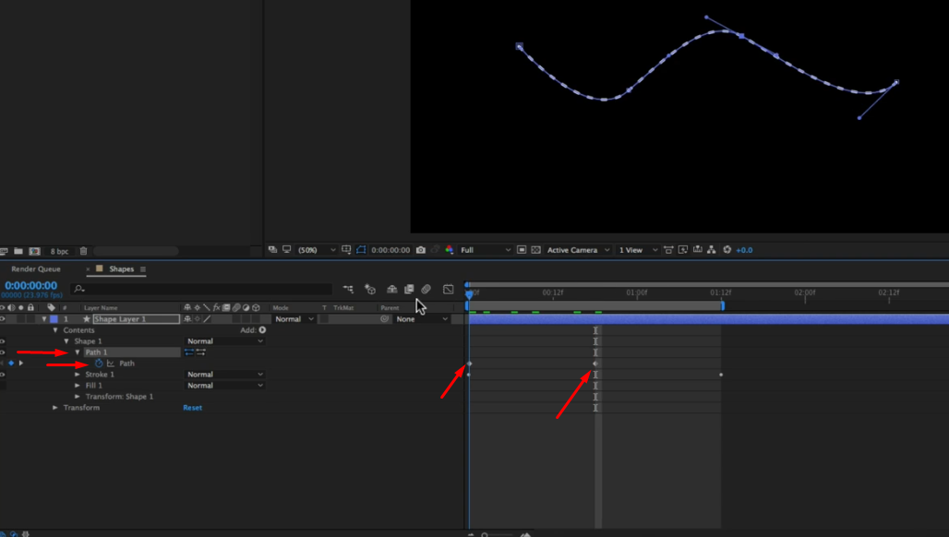



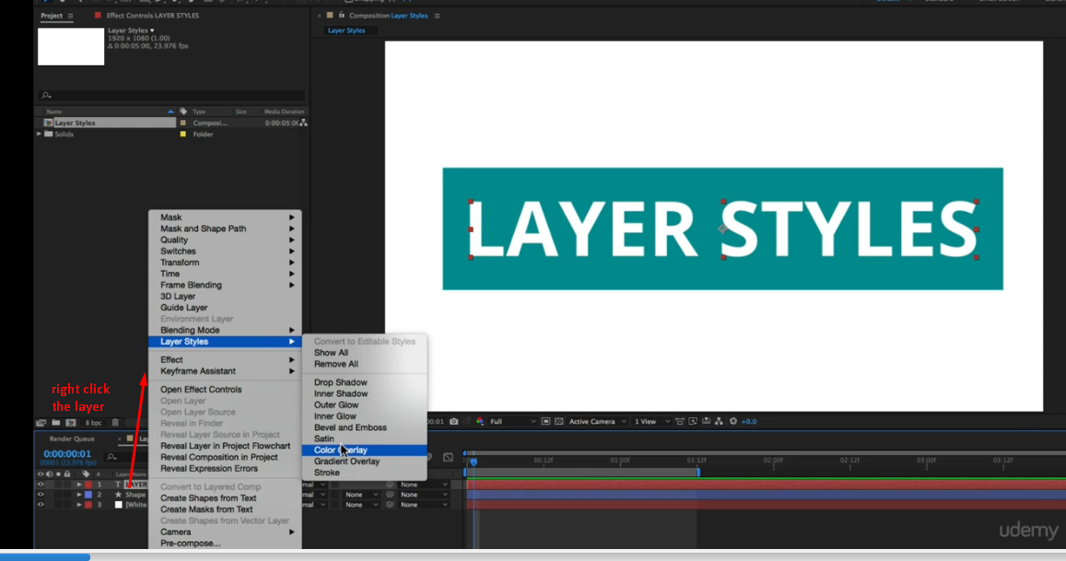

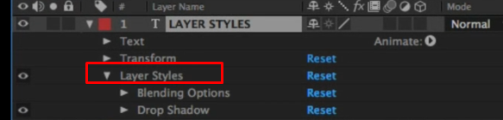



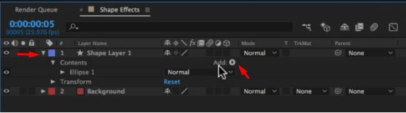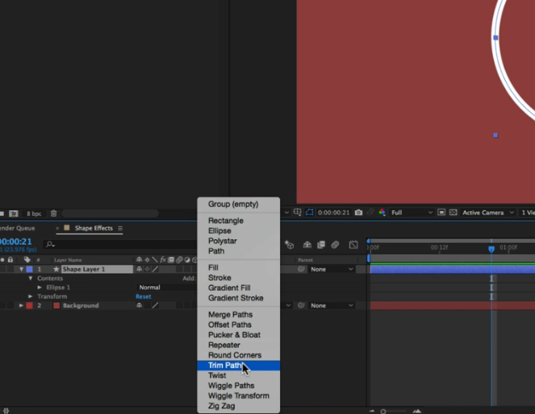

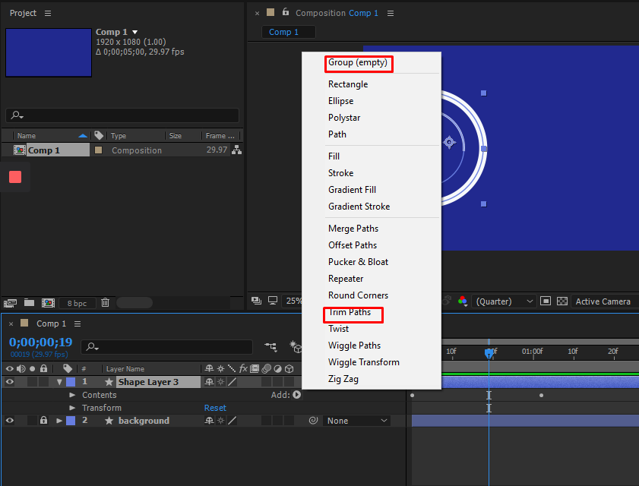

CTL + D = Duplicates

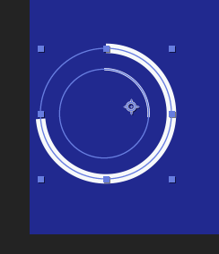 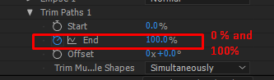

☺ happy to have learned some basics. I think now i am in a poisition to learn with projects.

Section Five



[easy ease , speed graph, blur works good together]

Trim path and track matte works fine together

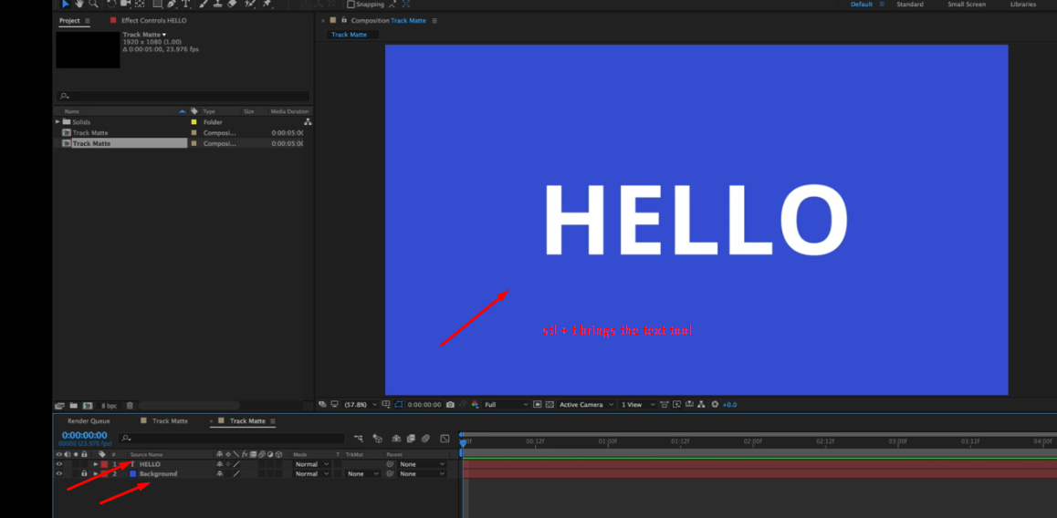

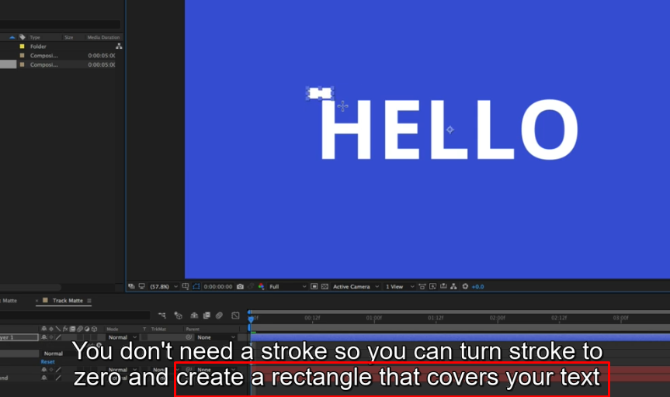

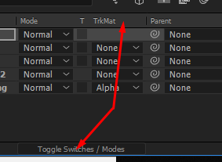

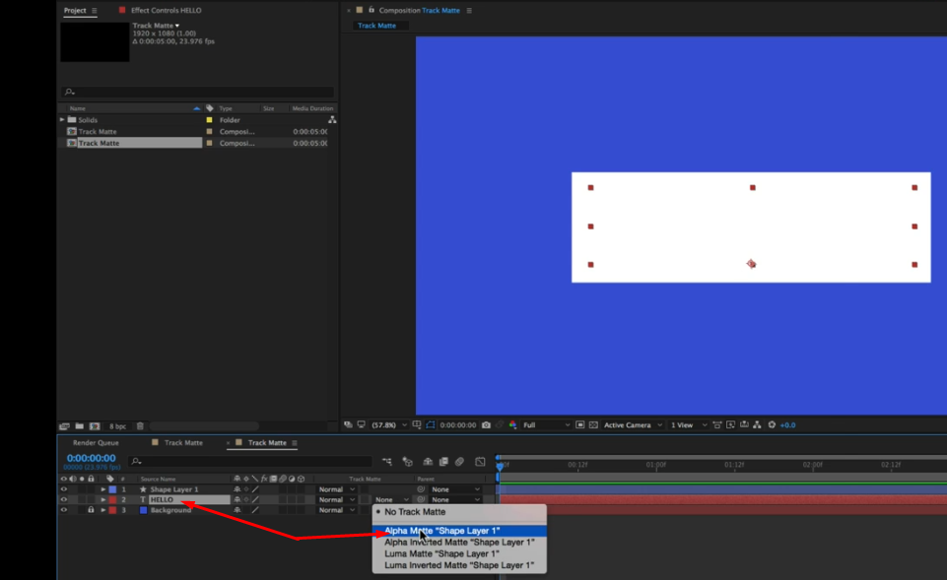

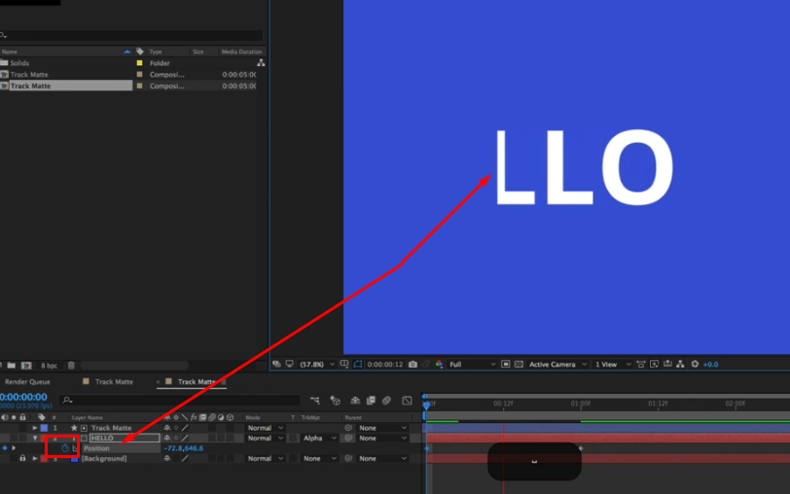

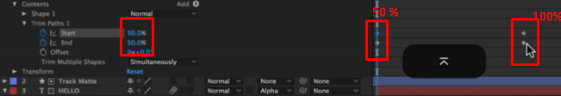

alt + ] on time indicator

ctl + ] on layer



Trim composition to work area **ctl+ shift+x**

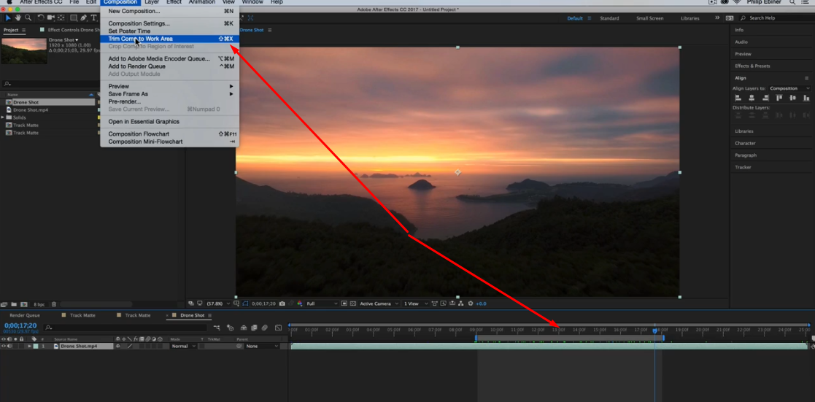

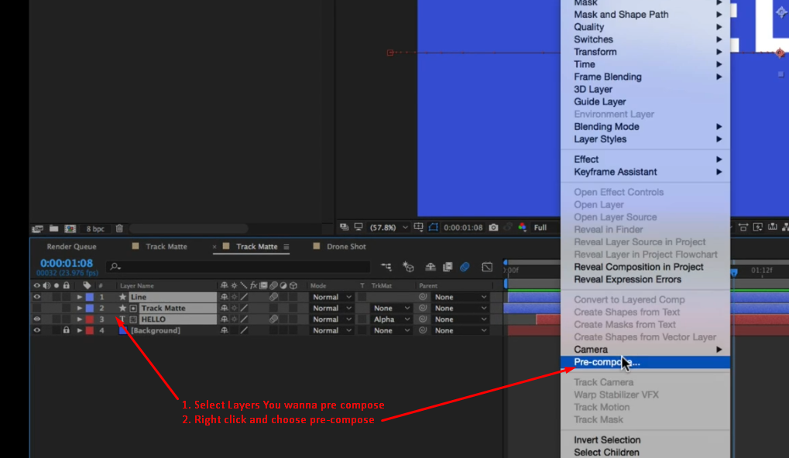

**Ctl + shift + c =** pre composition



Ctl + a = selects all the layers

U = bring up all keyframes we have adjusted

Ctrl+ d = duplicates layer

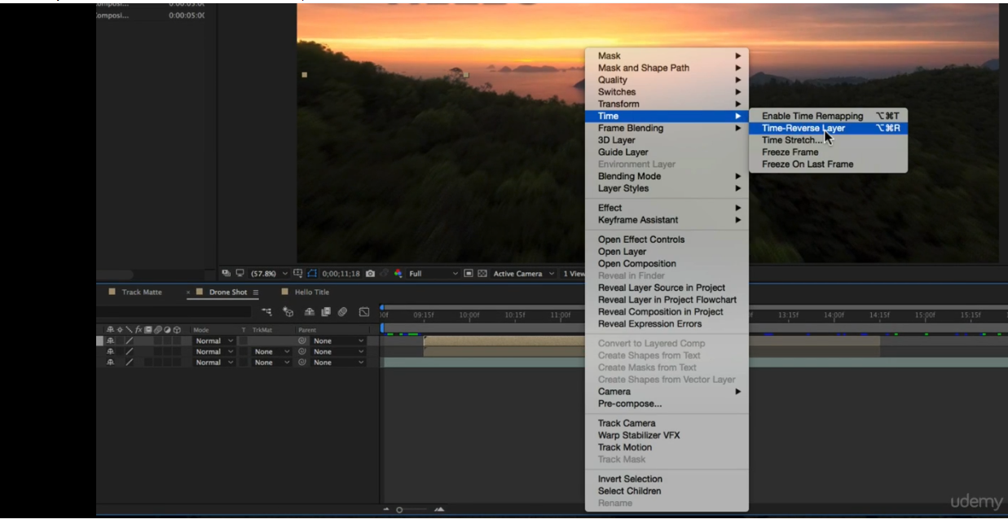



See the original video in order to understand it more.





